DMCI ALUMNI NEWSLETTER SNIPPETS

OCTOBER 2024

- POSTPONED! The fundraiser ‘Bud, Spud, and Steak’ will be postponed until further notice! Please watch out for updates in the next round of newsletter snippets and/or on our social media accounts linked at the end of this newsletter!

- The DMCI "Oshkii Ogitchidaa" (Young Warriors) Drumming Group performed at the Canada Life Centre on October 9th, 2024. The student lead traditional drum group performed the “Honour” song in front of all the staff in the entire Winnipeg School Division! They are led by Indigenous drum coaches Melvin Starr and Dwayne Gladue! More information about the event can be viewed via the school’s website linked here: https://www.winnipegsd.ca/danielmcintyre/_ci/p/30822

- Awards: Awards have been granted to exceptional students this past June 2024 convocation:
Award | Amount | Student name
Alumni 75th Scholarship | $ 1,000.00 | Gilbert Barcega
Barry Anderson DMCI Alumni Choir Award | $ 500.00 | Madeleine Flemington
Beverley Wong Memorial Scholarship | $ 500.00 | Alyssa Manalaysay
Chris and Fatima Ilagan Scholarship | $ 450.00 | Evgeniia Samoilova
Daniel McIntyre Alumni Award | $ 1,300.00 | Denise Doria
Daniel McIntyre Vocational-Tech Award | $ 500.00 | Margareth Baluyot
Joe Ogoms Award | $ 500.00 | Tricia Torres
Joe Ogoms Award | $ 500.00 | Caden Tugade
Johann Generao Award | $ 500.00 | One Miguel Ilagan
John Lawler Memorial Scholarship | $ 1,000.00 | Oromiva Wancha
Maroons Alumni Football Scholarship | $ 500.00 | Robal Marhay
Sherman Himelblau Memorial Award | $ 250.00 | Luis Manguerra
Takejiro Yamashita Memorial Bursary | $ 400.00 | John Cortez
William J.S. Brown Scholarship | $ 500.00 | Madeleine Flemington
Woman with Distinction Award | $ 500.00 | Not awarded due to insufficient funds in Award Account
Merit Award: Science | $ 250.00 | Dorothy Mae Santoyo
Merit Award: EAL | $ 250.00 | Bashe Mohammed Abdi
Merit Award: Art | $ 250.00 | Agatha Blanco
Merit Award: Dance | $ 250.00 | Marielle Toledo
Merit Award: Math | $ 250.00 | Hannah-Mae Tahimic
Merit Award: Music | $ 250.00 | Andrea Ramiro
Merit Award: Business Education | $ 250.00 | Daryna Rychanchyk
Merit Award: English | $ 250.00 | Alyssa Manalysay
Merit Award: Human Ecology | $ 250.00 | Marla Nagutom
Merit Award: Industrial Arts | $ 250.00 | Duncan Wilson
Merit Award: Physical Education | $ 250.00 | Brent Saludo
Merit Award: Social Studies | $ 250.00 | Ranseal Banados

NOVEMBER 2024
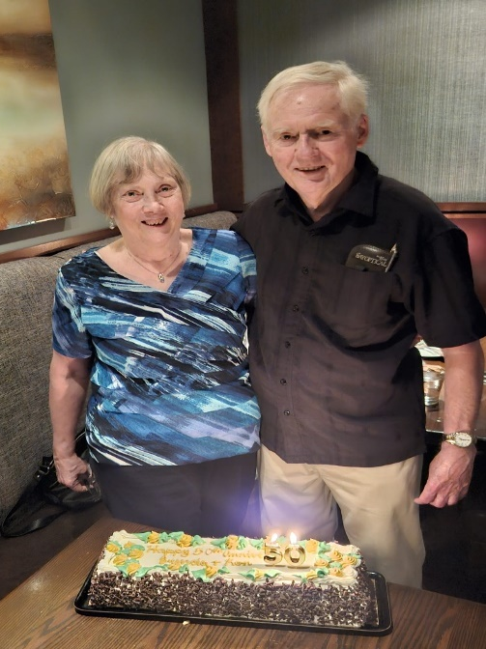
- Photographs: DMCI Alumni Ronald James Chapman (class of 1966) and Brenda Mary Cutforth (class of 1969) on their wedding day (left) and on their 50th Wedding Anniversary held in August 2024 (right).

DECEMBER 2024

- Giving Tuesday! Held each year on the first Tuesday after the American Thanksgiving, Giving Tuesday is a global movement that reimagines a world built upon shared humanity and radical generosity! Help us help DMCI students in reaching their full potential and build a brighter future for our world! It only takes one day to make a difference that lasts a lifetime! We greatly appreciate your support over the years and look forward to continuing our relationship with you!
  - Online donation is now also possible! Please visit our website linked below to access our online donation portal!

If you have any questions, comments, and/or concerns, please contact the DMCI Alumni Association at:

DMCI Alumni Association
Box 2475
Winnipeg, Manitoba, R3C 4A7
Email: info@dmcialumni.org
Website: https://www.dmcialumni.org/
Facebook: https://www.facebook.com/dmcialumni
Instagram: https://www.instagram.com/dmcialumni/
X (Twitter): https://www.x.com/dmcialumni/

